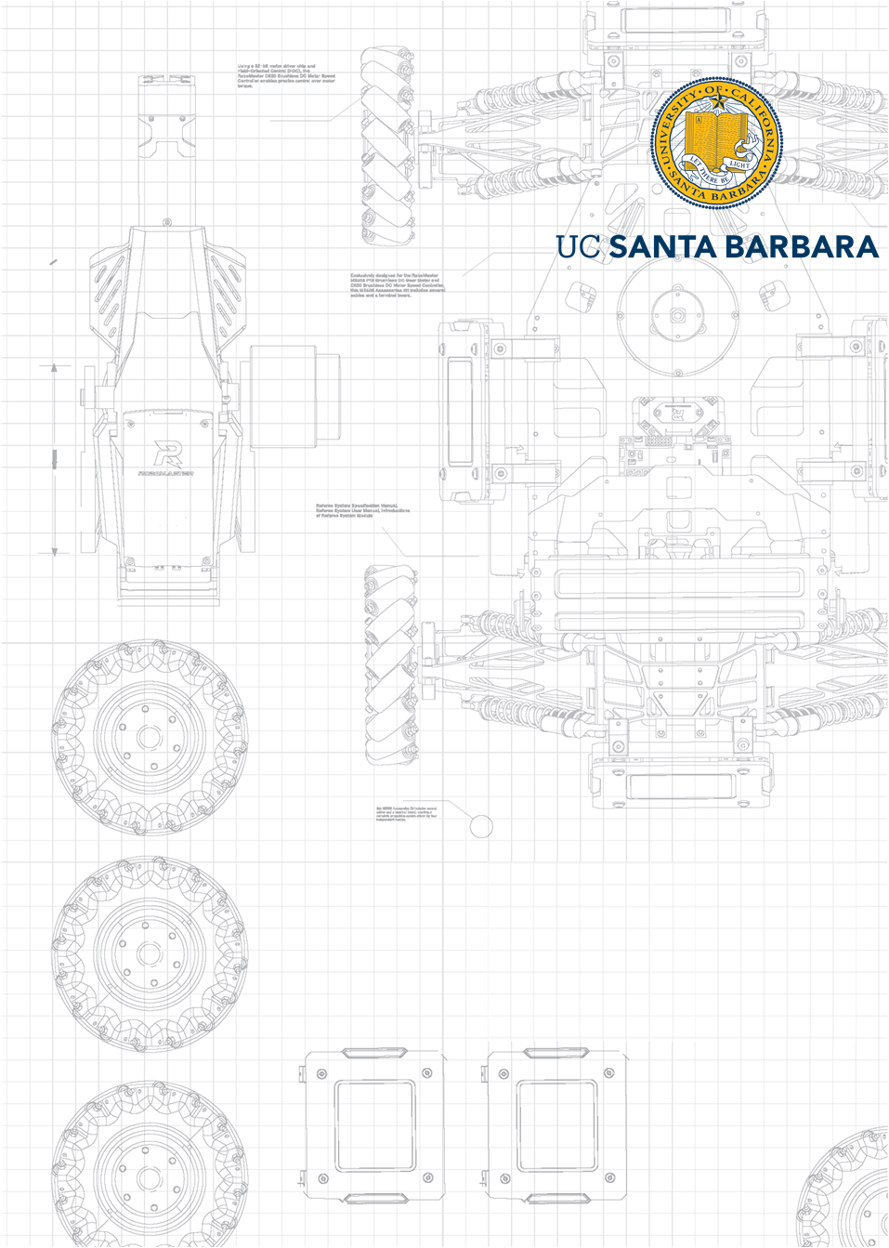x

**ECE 278C Assignment 6**

Peicheng Wu NetID：X311088

2024.03.03

Catalog

1. Platform: VScode 3

2. Question 3

2.1 Part A 3

2.2 Part B 4

3. Solutions 4

4. Results 5

4.1 Part A 5

4.2 Part B 5

4.3 Conclusion 5

5. Appendix 6

# Platform: VScode

Visual Studio Code, often referred to as VSCode, is a free and open-source code editor developed by Microsoft. It's renowned for its lightweight design, speed, and robust capabilities. Available for Windows, macOS, and Linux, VSCode offers built-in Git integration, an integrated terminal, and a debugger. Its power lies in its extensibility, with a vast marketplace of extensions that add support for various programming languages, debuggers, and tools. The editor's appearance and behavior are highly customizable, and its Intellisense feature provides smart code completions. Thanks to its open-source nature, it has a vibrant community that continually contributes to its development and enhancement.

# Question

The data set was taken over the walkway pavement in front of the Broida Hall. The ground-penetrating radar imaging unit scanned along a linear path and took data at 200 spatial positions. The spatial spacing between the data-collection positions is 0.0213 m (2.13 cm).

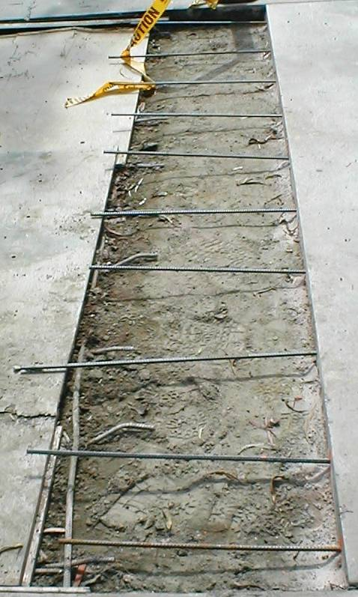

At each data-collection position, the system illuminates the walkway pavement with microwaves in the step-frequency monostatic mode, stepping through 128 frequencies with a constant increment, from **0.976 GHz to 2.00 GHz**. The relative permittivity **εr is approximately 6.0.**

The data set is organized in the form of a **(200 x 128) array**, corresponding to 128 complex-amplitude values (for the 128 frequencies) at 200 receiving positions.

## Part A

Your task is to perform the image reconstruction of the subsurface profile by using multi-frequency backward propagation, as you conducted in Assignment 4. There are 128 coherent sub-images, corresponding to the 128 frequencies (128 wavelengths). Your goal is to produce a 128-frame video to illustrate the convergence to the final image and the effect due to the increase of frequency bandwidth.

## Part B

Your task is to perform the image reconstruction of the subsurface profile by superimposing the range profiles, as you conducted in Assignment 5. There are 200 range profiles, corresponding to the 200 transceiver positions. Your goal is to produce a 200-frame video to illustrate the convergence to the final image and the effect due to the increase of data-acquisition aperture.

# Solutions

In the field we have equation:

$$g\left(x,y,z\right)=s\left(x,y,z\right)*h\left(s,y,z\right)$$

In last 2 homework, we just assume the source is impulse function:

$$s\left(x,y,z\right)=δ\left(x,y,z\right)$$

However, for now we need to figure out real world question, so we just need to change impulse function to the data we received:

$$s\left(x,y,z\right)=g\left(x,y,z\right)$$

Also, we use the FMCW system, Thus the g(x,y,z) actually is the frequency and number of receiver function:

$$g\left(x,y,z\right)=g\left(n,m\right)$$

Where n is the number of the receiver, m is the different frequencies. For this homework, the data in the MATLAB file it is F(n, m).

$$n = 1,2,… ,200$$

$$m = 1,2,…,128$$

According the backward propagation:

$$\dot{s}\left(x,y,z\right)=g\left(x,y,z\right)*h^{*}\left(x,y,z\right)$$

$$\{\}\{ =\iiint{g\left(n, m\right)exp\left(\frac{-j2π\left(2r^{'}\right)}{λ_{m}}\right)dx^{'}}dy^{'}dz^{'}$$

Where $r_{n}$ is defined by following equation:

$$r_{n}=\sqrt{{\left(x_{r}-x_{s}\right)}^{2}+{\left(y_{r}-y_{s}\right)}^{2}}$$

Where $λ_{m}$ is defined by following equation:

$$λ_{m}=\frac{3e8}{\sqrt{ϵ_{r}}×f\left(m\right)}$$

# Results

## Part A



**Fig.1 Reconstructed image with different frequency**

The image is just like assignment 4, with more frequency wave adding, the bar shows more obviously.

## Part B



**Fig.2 Reconstructed image with different receiver**

The image has been constructed by linear receivers.

## Conclusion

The whole processing steps is just like the assignment 4 and 5. However, there still are some problems when I did it. There are some tips I concluded:

* You should make sure the lambda is correct. Because the medium is ground, so the speed of waves will change because of different epsilon. I recommend to print all the lambda you calculated.
* Because the wave will spread to target and then come back. Thus, we need to use ${2r}_{n}$ to compute the backward propagation.
* The data, sometime we need to process data we got. For this time, the data we need to conjugate first or we will just reconstruct something weird.

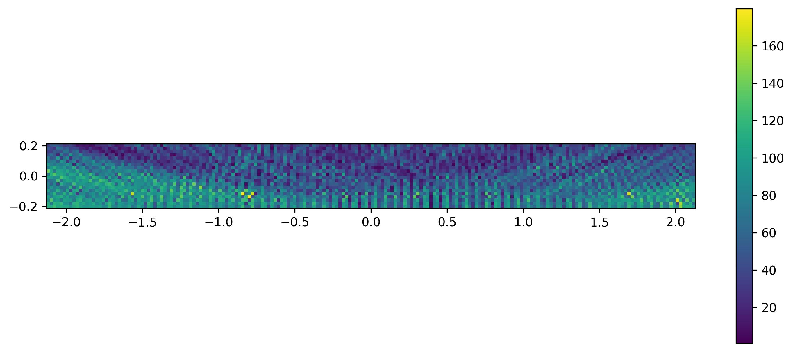

**Fig.3 Reconstructed image with non-conjugated data**

# Appendix

import numpy as np

import cupy as cp

import matplotlib.pyplot as plt

from scipy.fft import fft2, fftshift

import argparse

from tqdm import tqdm

from scipy.io import loadmat

def generate_receivers_locations(y_offset, span):

    delta_x = 0.0213/4

    num_points = int(span / delta_x)

    x_positions = np.linspace(-span/2, span/2, num_points)

    scatter_locations = [(x, y_offset) for x in x_positions]

    # print(scatter_locations)

    return scatter_locations

def generate_source_region(X_length, Y_length):

    delta_x = 0.0213/4

    num_points_x = int(X_length / delta_x)

    num_points_y = int(Y_length / delta_x)

    x_positions = np.linspace(-X_length/2, X_length/2, num_points_x)

    y_positions = np.linspace(0, Y_length, num_points_y)

    source_locations = [(x, y) for y in y_positions for x in x_positions]

    # print(source_locations)

    return source_locations

def calculate():

    X_length = 4.26

    Y_length = 0.213

    y_offset = 0

    span = 4.26

    mat_file_path = './gpr_data/gpr_data.mat'

    data = loadmat(mat_file_path)

    F = data['F']

    f = data['f']

    da = data['da']

    source_locations = generate_source_region(X_length, Y_length)

    num_points_x = int(X_length / (0.0213/4))

    num_points_y = int(Y_length / (0.0213/4))

    complex_wave = []

    # G = np.zeros((128,200),dtype=complex)

    if args.part_B:

        for receive in tqdm(range(200)):

            h_whole = np.zeros((num_points_y, num_points_x), dtype=complex)

            for idx, (x_s, y_s) in enumerate(source_locations):

                y_idx = idx // num_points_x

                x_idx = idx % num_points_x

                h = 0

                for n in range(128):

                    lambda_n = ((3e8/np.sqrt(6)) / f[0,n])

                    r_g = np.sqrt((da[0, receive] - 0)**2 + (0 - 0)**2)

                    x = F[n, receive].conjugate()

                    r_s = np.sqrt((x_s - (da[0, receive] - 2.13))**2 + (y_s - 0)**2)

                    h_n = x * np.exp(-1j * 2 * np.pi * (2 * r_s) / lambda_n)

                    h += h_n

                h_whole[y_idx, x_idx] = h

            complex_wave.append(h_whole)

        return complex_wave

    if args.part_B:

        for n in tqdm(range(128)):

            lambda_n = ((3e8/np.sqrt(6)) / f[0,n])

            h_whole = np.zeros((num_points_y, num_points_x), dtype=complex)

            for idx, (x_s, y_s) in enumerate(source_locations):

                y_idx = idx // num_points_x

                x_idx = idx % num_points_x

                h = 0

                for receive in range(200):

                    lambda_n = ((3e8/np.sqrt(6)) / f[0,n])

                    r_g = np.sqrt((da[0, receive] - 0)**2 + (0 - 0)**2)

                    x = F[n, receive].conjugate()

                    r_s = np.sqrt((x_s - (da[0, receive] - 2.13))**2 + (y_s - 0)**2)

                    h_n = x * np.exp(-1j * 2 * np.pi * (2 * r_s) / lambda_n)

                    h += h_n

                h_whole[y_idx, x_idx] = h

            complex_wave.append(h_whole)

        return complex_wave

if __name__ == "__main__":

    parser = argparse.ArgumentParser(description="choose time domain or frequency domain")

    parser.add_argument('--part_A', action='store_true', help='different frequency')

    parser.add_argument('--part_B', action='store_true', help='different receivers')

    args = parser.parse_args()

    complex_wave = calculate()

    np.save('F:/desktop/results/complex_wave.npy', complex_wave)

This file is to draw images we reconstructed.

import numpy as np

import cupy as cp

import matplotlib.pyplot as plt

from scipy.fft import fft2, fftshift

import argparse

from tqdm import tqdm

file_path = 'F:/desktop/results/complex_wave.npy'

complex_wave = np.load(file_path)

temp = np.zeros((10, 200), dtype=complex)

stack = np.zeros((10, 200), dtype=complex)

i = 0

for cw in tqdm(complex_wave):

    temp += cw

    plt.figure(figsize=(12, 5))

    plt.imshow(abs(temp), extent=(-2.13,2.13,0 ,0.213))

    plt.title('')

    # plt.colorbar()

    plt.savefig(f'F:\\desktop\\results\\{i}.png', dpi=300, bbox_inches='tight')

    plt.close()

    i += 1

You can also find the code on the github: [UCSB-ECE-278C/assignment3 at main · percyance/UCSB-ECE-278C (github.com)](https://github.com/percyance/UCSB-ECE-278C/tree/main/assignment3)

When you want to run: please type python assignment6.py –part_A or –part_B

part_A means we using different frequencies to reconstruct the image. part_B means using different receivers to reconstruct the image.

Then, you can draw the image by running read_np.py